**ASSIGNMENT-3**

**Name: Prabhnoor Singh Roll No: 102115059 Group:2NC3**

**Q1. Write a function to perform following operations on the string:**

**(Note: You can make single function for all operations/independent function for each problem)**

**i. Finding length of a string ii. Converting a string in lowercase**

**iii. Counting number of words and vowels in a string iv. Validating a string (Note: Valid string does contain only alphabets)**

**v. Reversing a string (Eg. Code** → **edoC) vi. Checking if a string is palindrome.**

**vii. Finding duplicate characters in a string (Note: print the duplicate characters only once, irrespective of the number of times it occurred)**

#include <iostream> using namespace std;

int length(string str){ int l=0;

for(int i=0;str[i]!='\0';i++) l=l+1; return l;

}

string lowerCase(string str,int l){ for(int i=0;i<l;i++){ if(str[i]>=65 && str[i]<=90)

str[i]=str[i]+32;

}

return str;

}

void count(string str,int l){ int v=0,sc=0;

for(int i=0;i<l;i++){

if(str[i]==97 || str[i]==101 || str[i]==105 || str[i]==111 ||

str[i]==117) v=v+1; else if(str[i]<97 || str[i]>122)

sc=sc+1;

}

cout<<"Words: "<<l-v-sc<<" Vowels: "<<v<<endl;

}

void validate(string str,int l){ int flag=1;

for(int i=0;i<l;i++){ if(str[i]<97 || str[i]>122){ flag=0; break;

}

}

if(flag==1)

cout<<"String is valid"<<endl; else cout<<"String is not valid"<<endl;

}

string reverse(string str,int l){

char temp;

for(int i=0,j=l-1;i<l/2;i++,j--){ temp=str[i];

str[i]=str[j];

str[j]=temp;

}

return str;

}

void palindrome(string str,string rstr){

if(str==rstr)

cout<<"String is Palindrome"<<endl; else

cout<<"String is not Palindrome"<<endl;

}

void duplicate(string str,int l){ char nstr[l]; int c=0;

for(int i=0;i<l;i++){ int j; for(j=0;j<i;j++){ if (str[i]==str[j])

break;

} if(j==i){

nstr[c] = str[i]; c=c+1;

}

}

cout<<"String with distinct element: ";

for(int i=0;i<c;i++) cout<<nstr[i]; cout<<endl;

}

int main(){

string str,rstr,lstr,lrstr;

cout<<”Enter String”; cin>>str; int l; l=length(str);

cout<<"Length is: "<<l<<endl;

lstr=lowerCase(str,l);

cout<<"String in lower case: "<<lstr<<endl;

count(lstr,l); validate(lstr,l); rstr=reverse(str,l);

cout<<"Reverse of string is: "<<rstr<<endl;

lrstr=lowerCase(rstr,l); palindrome(lstr,lrstr); duplicate(lstr,l);

return 0;

}

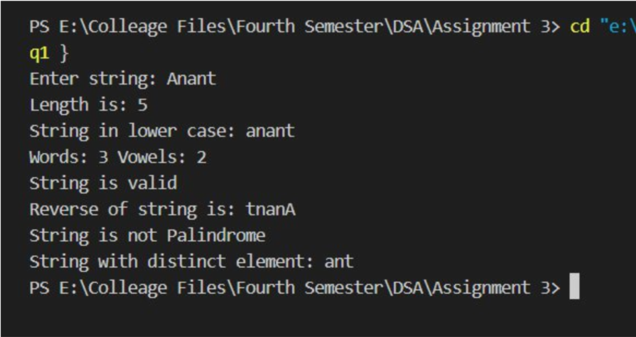

**Q2 Write a program for finding the factorial of a number recursively**

#include <iostream> using namespace std;

int factorial(int num){ if(num==0) return 1; return num*factorial(num-1);

}

int main(){ int num,fact; cout<<"Enter number: "; cin>>num;

fact=factorial(num);

cout<<num<<"! = "<<fact<<endl;

}

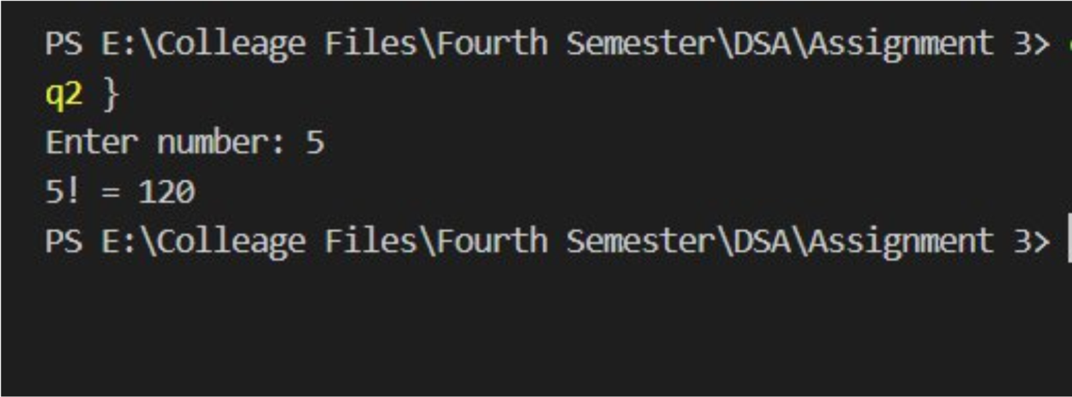

**Q3. Implement combination formula nCr using recursion and code it in C/C++/JAVA/Python language.**

#include <iostream> #include <cmath> using namespace std;

float combination(float n,float r){

if(n<r)

return 0; else if(r==0) return 1; return (n/r)*combination(n-1,r-1);

}

int main(){ int n,r; float ans; cout<<"N=: "; cin>>n; cout<<"R=: ";

cin>>r; ans=combination(n,r); cout<<n<<"C"<<r<<": "<<ans<<endl;

}

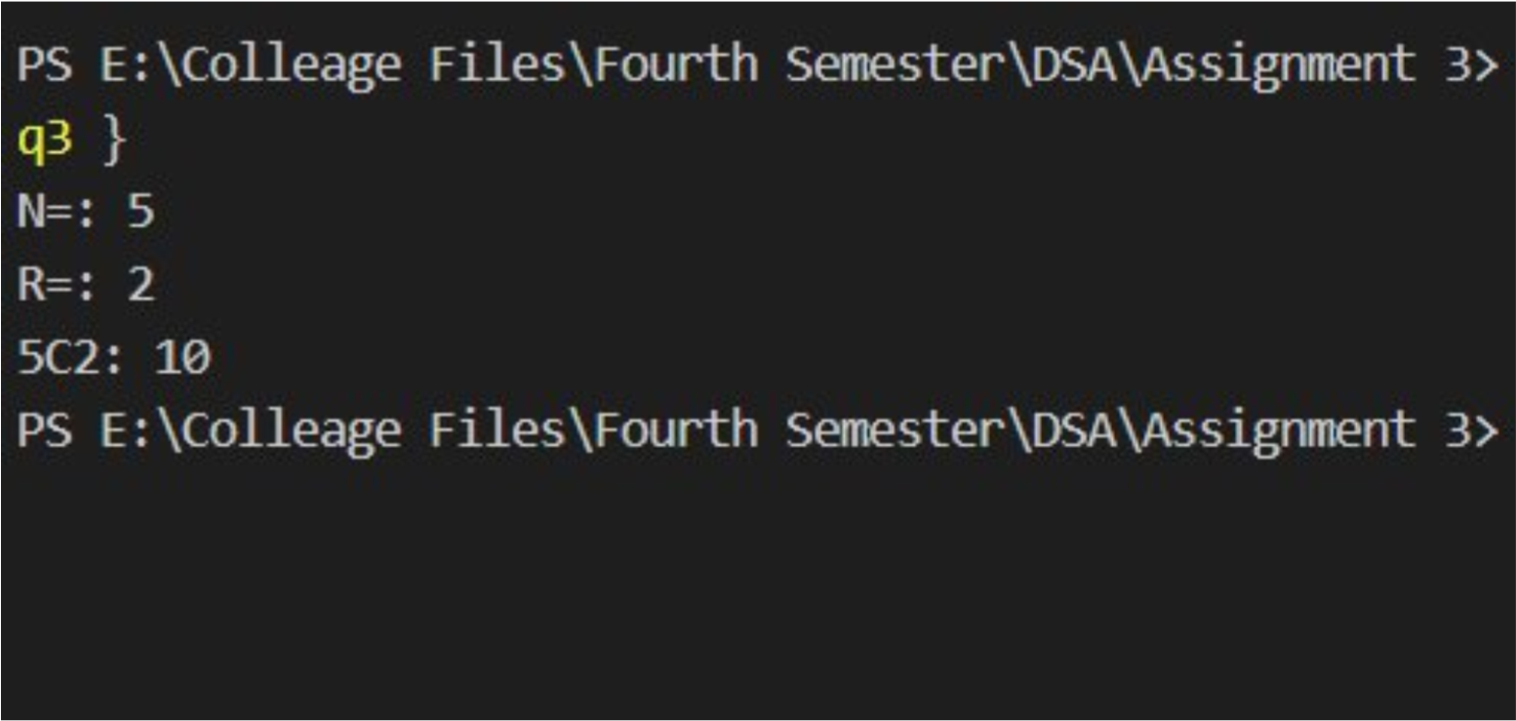

**Q4. Implement the Tower of Hanoi Problem using recursion and code it in C/C++/JAVA/Python language.**

#include <iostream> using namespace std; void towerOfHanoi(int n,char beg,char aux,char end){

if(n==0) return; towerOfHanoi(n-1,beg,end,aux); cout<<"Disk "<<n<<" : "<<beg<<" -> "<<end<<endl; towerOfHanoi(n-1,aux,beg,end);

}

int main(){ int n;

cout<<"Enter number of rod: ";

cin>>n; towerOfHanoi(n,'A','B','C');

return 0;

}

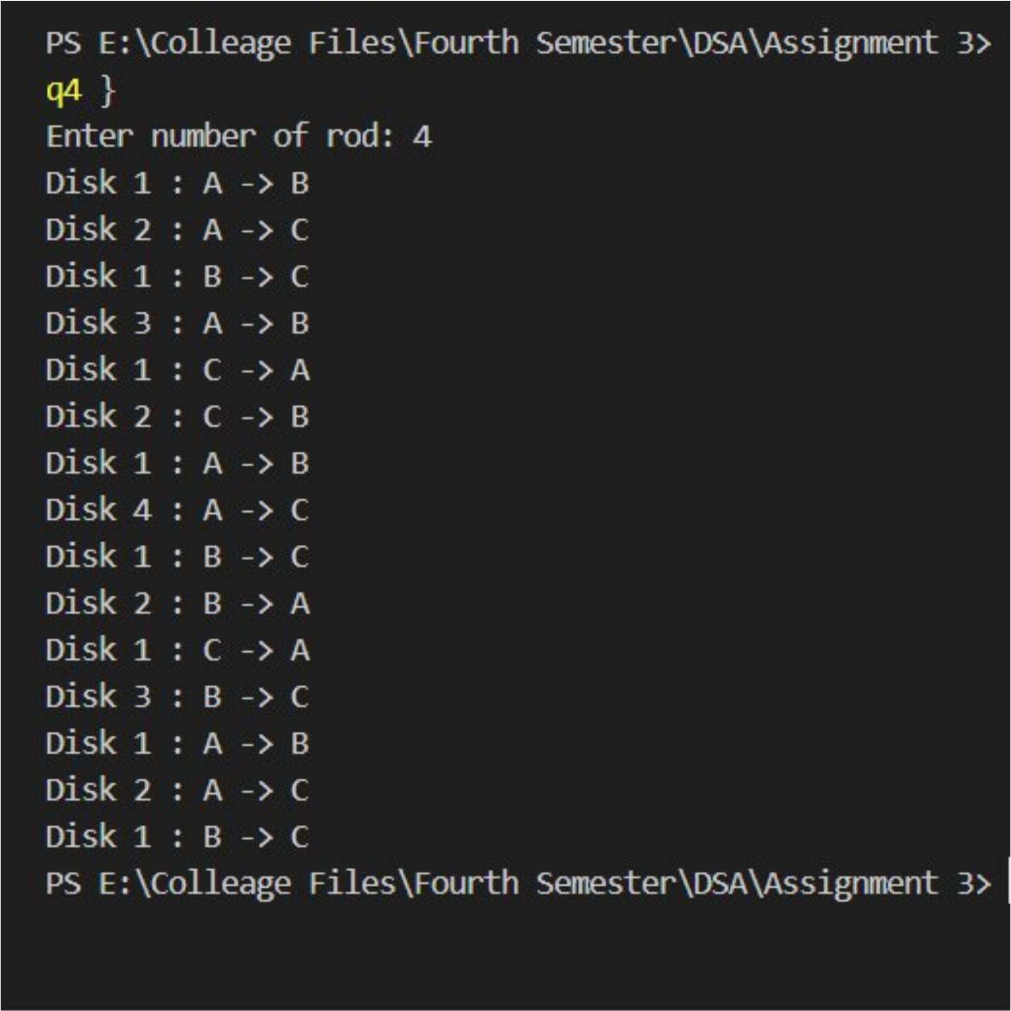

**Q5. Implement the Fibonacci series using recursion and code it in C/C++/JAVA/Python language**

#include <iostream> using namespace std;

int fibonacci(int n){

if(n==1 || n==0) return n; return fibonacci(n-1)+fibonacci(n-2);

}

int main(){

int n,fib;

cout<<"Enter position: "; cin>>n; fib=fibonacci(n);

cout<<"Fibonacci number is: "<<fib<<endl; return 0;

}

